# Using ORACLE server 12c

**Lab 1 1 % Due September 21, 2017 midnight via BLearn**

Use your Oracle USER ID STxx on BTACS server database.

* Use the SQL Developer HELP (Tutorial: Creating Objects for a Small Database) to find the Script to create library objects. This small library schema has three tables: BOOKS, PATRONS, and TRANSACTIONS. Additionally, the script has a sequence, a view, a trigger, and a stored procedure.
* Run the script to create the database and to insert the data.

1. Use the following box and indicate the primary and foreign keys:

books (book\_id, title, author\_last\_name, author\_first\_name, rating)

patrons (patron\_id, last\_name, first\_name, street\_address, city\_state\_zip, location)

transactions (transaction\_id, patron\_id, book\_id, transaction\_date, transaction\_type)

Please note the following codes: transaction code 1 = checking out, 2 = returning 3 = placing a hold

Primary Keys highlighted in pink

Foreign Keys highlighted in yellow

1. Create SQL statements to add
   1. Yourself as a patron

INSERT INTO PATRONS VALUES (

patron\_id\_seq.nextval,

'Bilkhu',

'Jagjit',

'1610 Greenfield Avenue',

'Kamloops BC V2B4N3',

null);

* 1. Our textbook as a book (with high rating!)

INSERT INTO BOOKS VALUES (

'0132943263',

'Database Systems: A Practical Approach to Design, Implementation, and Management',

'Connolly',

'Thomas',

10);

* 1. Transaction to take the book out from the library. Use today’s date and time as a transaction date and time.

INSERT INTO TRANSACTIONS (transaction\_id, patron\_id,book\_id,transaction\_date,transaction\_type)

VALUES (1000, '100,'0132943263', SYSDATE, 1);

1. Prepare a select statement to list all patrons ordered by the last name (this list should include your name).

SELECT \* FROM patrons ORDER BY LAST\_NAME;

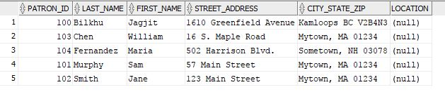

1. Write an SQL query to list all tables created by you (USER\_TABLES). List the table names only.

SELECT TABLE\_NAME FROM USER\_TABLES;

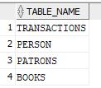

1. Write an SQL query to list all tables, sequences, and indexes created by you (USER\_OBJECTS). List the names of the objects, types, and date and time of their creation.

SELECT OBJECT\_NAME, OBJECT\_TYPE, CREATED FROM USER\_OBJECTS;

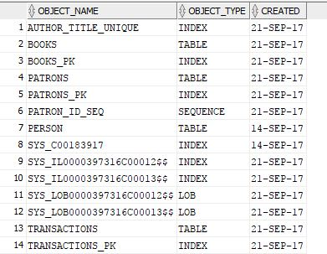

1. Write an SQL query to display current **date and time** using **ISO 8601 date/time standard with the local time zone.**
   1. Using the date/time from the Oracle server

SELECT to\_char (SYSDATE,'YYYY-MM-DD HH24:MI:SS') FROM DUAL;

**C:\Users\T00533766\AppData\Local\Microsoft\Windows\INetCache\Content.Word\sysdate.jpg**

* 1. Using the date/time from the user session (client session using SQLDeveloper).

SELECT to\_char (CURRENT\_DATE,'YYYY-MM-DD HH24:MI:SS') FROM DUAL;

**C:\Users\T00533766\AppData\Local\Microsoft\Windows\INetCache\Content.Word\current_date.jpg**

1. Write an SQL query to display the name of day spelled out in English (e.g., Monday, Tuesday…) of your date of birth. You may use TO\_CHAR () and TO\_DATE () to convert between strings and date.

SELECT to\_char (to\_date('1995/10/05','YYYY/MM/DD'),'DAY - MONTH - YYYY') FROM DUAL;

C:\Users\T00533766\AppData\Local\Microsoft\Windows\INetCache\Content.Word\dob.jpg

**Submit the answer as a pdf file**

1. List of the tables and their primary and foreign keys. (Box above)

2. SQL queries and their results for questions 2-7.